**Project Report: Games Sales and Ratings Analysis**

**1. Introduction**

This report presents an analysis of global video game sales and audience ratings. The objective of this project is to identify key trends in the gaming industry, understand the performance of different genres, and analyze the relationship between sales and user ratings across various regions.

**2. Project Objectives**

* Analyze global sales performance across different genres.
* Evaluate the distribution of user ratings by genre and correlate them with sales figures.
* Compare regional sales (Japan, North America, and Europe) to understand geographic preferences.
* Identify top-performing games and publishers in the market.
* Provide actionable insights through an interactive Power BI dashboard.

**3. Data Overview**

- Source: Data includes game sales, user ratings, genres, and publisher information.

- **Key Columns:**

* **Game Name:** The title of the game.
* **Genre:** The category of the game (e.g., Action, Shooter).
* **Sales:** Regional sales data from Japan, North America, and Europe.
* **User Rating:** Audience rating of games on a scale from A to E.
* **Publisher**: The company responsible for releasing the game.

**4. Methodology**

**Data Preparation:**

* Normalization: Converted categorical ratings (A, B, C, etc.) into numeric equivalents (A=5, B=4, ..., E=1) for analysis.
* Aggregation: Sales data aggregated by region and genre.

**Visualization Techniques:**

* KPI Indicators: Used to display total sales, average user ratings, and the number of
* publishers
* Bar Charts: To compare sales across genres and identify top games.
* Pie Charts: To visualize the user rating between each genre.
* Treemap: To show sales distribution by genre and publisher.
* Slicers: Added for interactivity, allowing users to filter by genre, region, and publisher.

**5. Key Findings**

**Global Sales:**

* Total global sales amounted to 864.45 million units.
* Action and Role-Playing games are the most popular genres, dominating sales figures

**Regional Insights:**

* Japan: Preference for Role-Playing and Action games.
* North America: Strong sales in Shooter and Action genres.
* Europe: Balanced distribution across genres with significant interest in Strategy and Platform games.

**User Ratings:**

* The average user rating is 2.83, with the highest ratings seen in the Shooter and Role-Playing genres.
* Games with higher user ratings generally showed better sales performance, indicating a positive correlation between quality and sales.

**Publisher Performance:**

* Top Publishers: Ubisoft, Rockstar Games, and Electronic Arts lead in terms of both the number of games released and total sales.

**6. Dashboard Design**

The dashboard is structured into three main sections:

* Top Section: Displays key metrics (Total Sales, Average Rating, Number of Publishers) using KPI indicators.
* Middle Section: Sales trends over time and genre-wise distribution of sales.
* Bottom Section: Detailed insights on the relationship between sales and user ratings, along with a treemap showing sales by genre and publisher.
* Interactive Elements: Slicers for filtering by genre, region, and publisher.

**7. Conclusion**

The analysis highlights key trends in the gaming industry, with Action and Role-Playing games showing strong performance across regions. The relationship between user ratings and sales suggests that quality, as perceived by users, is a critical factor in driving sales. The interactive dashboard provides a comprehensive view of the data, allowing stakeholders to explore various aspects of the gaming market.

**8. Recommendations**

* For Publishers: Focus on developing high-quality games in popular genres like Action and Role-Playing to maximize sales.
* For Regional Strategy: Tailor game offerings to regional preferences, with a focus on Shooter and Strategy games in Europe and North America.
* Future Research: Incorporate additional metrics like marketing spend and platform distribution (e.g., console vs. PC) to gain deeper insights.

**9. Appendix**

* Screenshots of the Dashboard: Include images of the different sections of the Power BI dashboard.
* Data Transformation Steps: Document the steps taken in Power Query for data preparation and normalization.

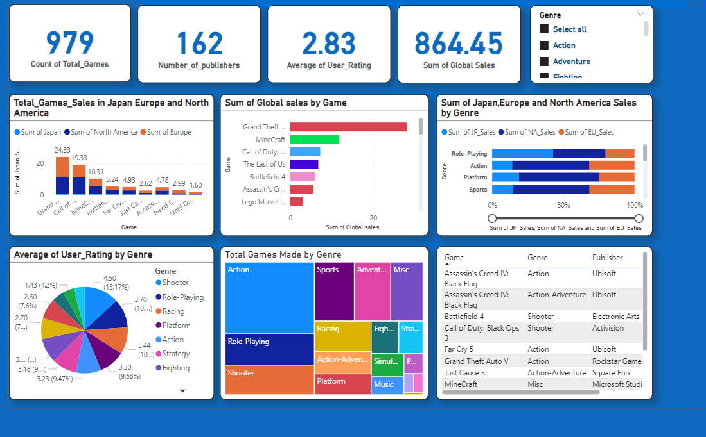

**Fig- Project Dashboard**